 

**Joint Statement:**

**Responding to Severe Weather Conditions**

This joint statement has been produced as a guide to approach such exceptional circumstances and in recognition of the outstanding dedication and efforts of all Parcelforce employees. Despite those efforts there may be occasions when it is impossible either individually or collectively to carryout our operational responsibilities and this joint statement seeks to clarify our approach.

It is the responsibility of every employee under his or her contract of employment to make every effort to attend for work within their scheduled duty time. Every employee will be expected to make every effort to report to their normal place of work and to use their initiative in getting to and from work without placing themselves in unnecessary danger.

Against that backdrop and to assist the development of local solutions we offer the following leadership;

Employee Does not Attend (Depot Open) – Choice of taking annual leave (which includes SA), making up hours on return to work (no SA paid) or make up full hours and SA hours (then SA will be paid) each case will be considered on its own merit inline with the above.

Employee Does not Attend (Depot Closed) – No requirement to take annual leave or make up hours – standard hours only paid.

Employee Does Attend and Depot Closes after Attendance – after efforts to perform the operation the depot closes because of unsafe working conditions or other agreed reasons – full hours (Inc SA) paid.

In addition and in exceptional circumstances our existing ‘Special Leave’ arrangements recognise that individuals may need in some cases (emergencies) to take time off from work in addition to annual leave. It is discretionary leave which can be fully paid and each case should be considered on its merits taking full account of the needs of the employee, the community and Parcelforce (mutual interest).

The criteria used to make decisions on the type of special leave appropriate to this situation and the development of local operational solutions will be consistent with our partnership approach, involving the local CWU in achieving a consensus on a fair approach to a rare situation.

Clearing Any Backlog – Where possible and if practical priority will be given to the use of directly employed staff to enable them to recover any lost earnings during such extreme circumstances

Thank you.

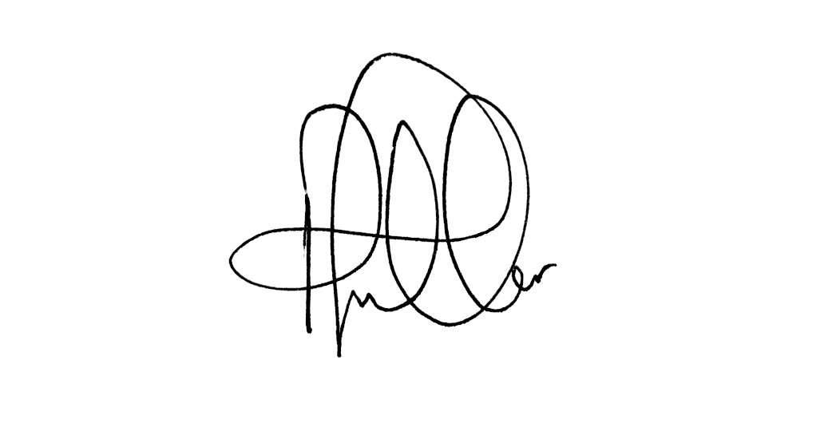



Terry Pullinger Peter Fuller

CWU Assistant Secretary Parcelforce Worldwide