How to operate a
Internal - Status
Compact Sequence Sorter (CSS)

 | 0.42
Steve Anning  Walk Sequencing Design & Integration Manager | 19th July 2009

Document Information

Basic Information

Information | Status
Release / Issue Date
Effective Date (If relevant)
Review Date (If relevant)
Author | Steve Anning
Contributors | Les Curtis, Ged Dermody, Neil Collett-Simpson, Jane Dillon, Tracey Tavender

Contact Details

Name | Address and Telephone Number
If you have any queries regarding this document, please contact:
Steve Anning | Mobile: 07889 946005  Mobex: 5367 2290

Change History

Version | Date | Details of Change
0.1 | 2nd July 2009 | Initial draft of document for comment
0.2 |  | Second Draft following input from contributors
0.3 | 4th Feb 2010 | Amended to include process for manual rejects re autobilling.

Table of Contents
Document Information 2
Table of Contents 3
Introduction 4
Purpose and Scope 4
CSS Staffing 5
CSS - Operator Role 5
Preparation of Work Area 5
Load the correct mode/ sortplan 6
Reasons for Sort Plan Load Failure 7
Load the Mail 7
Clearance of Jams 8
Rejects 9
Sequencing Mail 9
Full Size batches. (eg Wave 1) 10
Smaller batches. (eg Wave 2) 11
Cleardown 12
Other Sorting Functionality 13
Walk Sorting 13
Loading a Walk Sorting Plan 14
Load the Mail 15
Clearing the Mail 16
Batch Sorting 17
Loading a Batch Sorting Plan 18
Load the Mail 19
Clearing the Mail 20

Introduction

Purpose and Scope
This document is designed to give Managers and Operators the information they need to operate a Compact Sequence Sorter (CSS) and also to operate multiple CSS’s within a Mail Centre or Mail Preparation Unit (MPU). If the document has any gaps then please contact the document author who will try to add that information.

The key aim of automated mail processing is to maximise the volume of mail effectively processed through the automated mails pipeline at minimum cost. The actual methods of operation used will have a major effect on this.

CSS Staffing

CSS - Operator Role
- The CSS is designed for single person operations. It is the responsibility of the CSS operator to load, operate and unload the machine using the safe systems of work.
- The CSS Operator will also perform Preventive and Corrective (TPM) maintenance tasks as agreed and trained to do.
- Due to the intensive nature of the work and the need for consistent accuracy of the re-feed process, it is recommended that operators are changed at regular intervals throughout a shift. A period of 2 hours is considered a reasonable period of time to operate the machine without a break.

Preparation of Work Area

- Prepare machine for running by ensuring the correct containers are placed around the machine.
- Carry out the Total Productive Maintenance (TPM) activities as scheduled.
- There are three key components that make up the initial area setup (layout) and these are:
- The machine is completely empty of mail and trays. The sliding trolley should be positioned adjacent to stacker 20.
- A York of batched mail for processing (there may be more than one and the example layout below shows two).
- 1 x York containing empty trays

Batch
2
Moving Infeed Belt
Retaining Ridge
Static machine bed plate
Sliding
Trolley
Batch
1
Empty
Trays

Mail for sequencing will be presented in trays in York containers and will be labelled with a batch number. A batch is a group of walks for a delivery office. A batch segregation process will be necessary. This will take place at either the Mail Centre or at the DO Mail Processing Unit dependent on local circumstances. For large groupings of machines in Mail Centres a batch consolidation area will be necessary to consolidate trays that are despatched from multiple IMPs/iLSMs

Load the correct mode/ sortplan

Load the appropriate Operating mode and Sort plan. Using the CSS Touch screen (HMI) and pressing the appropriate icons on the HMI screen
- Log in to system as an Operator
- Select Sequencing mode.
- Select required sort plan.
Select the sequencing mode using the icons at the top of the HMI.

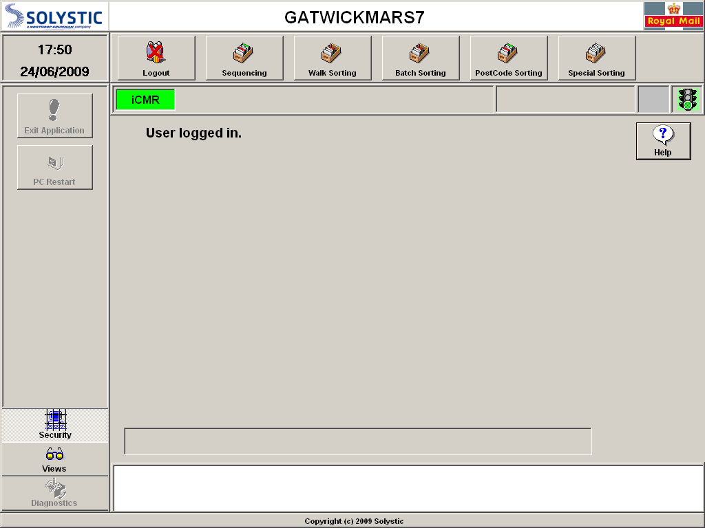

Next select the sort plan from the list displayed by touching the appropriate plan and selecting add.

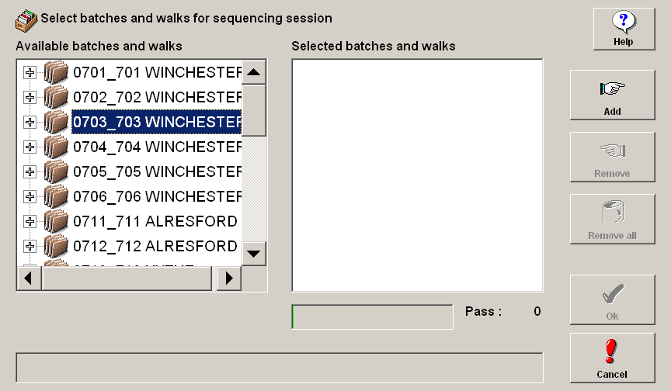

The sort plan will now load. The CSS will calculate if there is enough capacity to perform the sequencing sort plan. If successful the plan will appear in the right hand box and the bar below the box will display green the amount of capacity it will use.

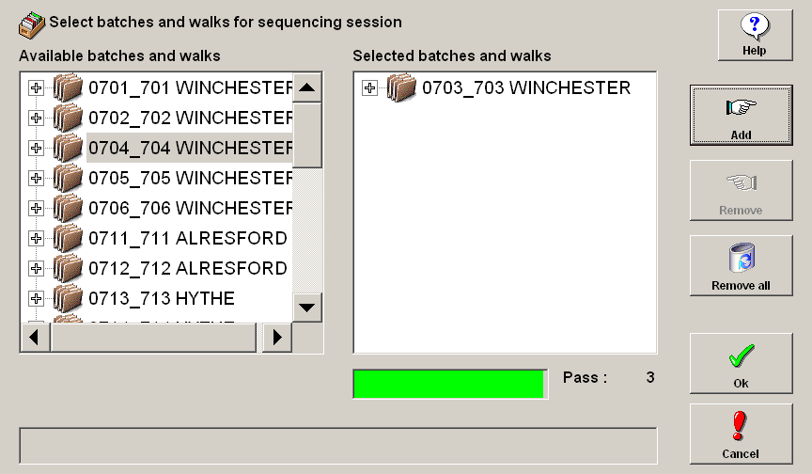

Reasons for Sort Plan Load Failure

If the sort plan is unable to load, the indicator bar will turn red.

- A data refresh may have resulted in additional delivery points being added to the batch beyond the limit that a sort plan can be created.
- A faulty stacker has been removed from operation and there is no longer capacity to load the plan.
- Two sort plans are loaded which has exceeded the delivery point capacity
Should either of the above occur, one or more walks will need to be removed from the plan.

Load the Mail

- Load 5 trays of mail on to the infeed. Mail must be orientated with the indicia upwards and the back of the mail towards the feeder belt. Put the empty trays on the racks underneath the infeed.
- If tipping a tray, the recommended method is to rest the tray on the front edge of the machine and tip the tray forwards. Spinning a tray towards you is not recommended as this causes excessive stress to the wrists and can result in injury.
- If mail is inverted with the indicia up, place the tray on the sliding trolley, adjacent to the loading area and lift mail on to the feeder in manageable size bundles. This ensures that the tray is at the correct height for lifting the mail. It is also recommended that mail handling gloves are worn for both protection and to aid the gripping of the mail.
- If loading from a loose letter rack then load one tier.
- It is important to ensure that mail is referenced to its bottom edge, not packed too tightly and is leaning backwards,and the feeder pushplate is against the stack. This reduces the risk of feeder jams.
- Press OK on the HMI. (As soon as you press OK the MIS counter starts),and pull the Destacker cover across .(See Figure 1)
- Press the conveyor ON on the Operator Control Panel (OCP) and when machine informs you (by a steady light) press the feeder ON button on the OCP.
- Insert Blue (Walk Separator) and Yellow (Postcode sequence) cards. (At least as many as indicated on the touch screen with a few additional ones to cover any card sorting failure).
- Load the remaining trays of mail or tiers of the loose letter rack. Again place the empty trays in the racks underneath the infeed with the label slot facing outwards. If this is full place the tray on the York of empty trays. When loading from loose letter trolleys each of the racks beneath the infeed must be populated with an empty tray ready for cleardown after pass three.
- Insert Green Pass separator cards at the end of the mail stack. (A minimum of 40).

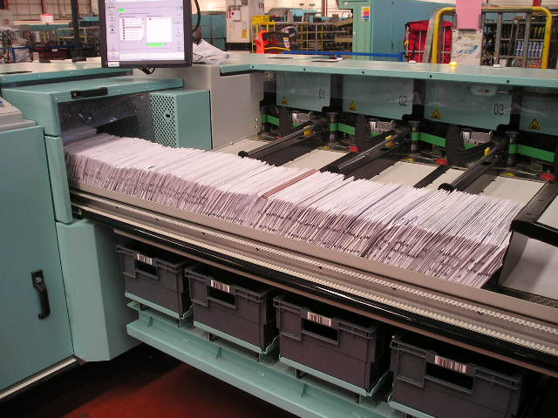Figure 1

Clearance of Jams

- If a jam occurs, press the RED stop button on the appropriate cover even if the machine has already stopped. Lift the cover to its full height and clear the jam.
- When the jam has been cleared close the cover using the handle on the cover, release the RED stop button, on the OCP press the BLUE emergency stop reset button and restart the machine by pressing the conveyor on and feeder on buttons.
- Mail no longer suitable for machining must be passed for manual processing.
- Mail suitable for re-feeding can only be re-fed whilst running a first pass, all other mail must be passed for manual processing.
- When clearing a jam, ensure the area before and after the jam is checked and cleared to prevent jam re-occurring on start up.

Rejects

- On Pass 1, it is permissible to re-feed rejects if by visual check the majority appear to be fully coded items for the batch being run. However, you must ensure the contents of stacker 20 are re-fed before the Green separator cards. Contents of stacker 20 on subsequent passes must be manually processed.

- A flick check of the rejects should be performed and items for other offices extracted and re-circulated as missorts. If the level of rejects rises above the normal level, investigate the problem.

- Any mail that is rejected after re-running the first pass rejects should be placed in a tray that should be positioned on the sliding trolley adjacent to stacker 20. When the tray is full or on completion of the batch it should be removed from the sliding trolley and sent to the primary sorting area. If this is within another office then the rejects should be sent in the same York as the sequenced mail and clearly labelled as rejects from batch xxx.

NOTE: A BLUE LABEL MUST BE USED FOR CSS REJECT TRAYS INDICATING THAT ANY RESPONSE SERVICE ITEMS WITHIN THE TRAY HAVE BEEN AUTOBILLED

Sequencing Mail

To fully sequence a batch of mail it must pass through the CSS three times. It is not until the third pass is completed that there is any form of recognisable order to the mail. It is therefore necessary that the three passes are completed to achieve the sequence. The pass order is shown on the HMI

An optimum batch size is between 4.5k and 6k. This allows the operator a sufficient amount of time to complete each task whilst maintaining the optimal balance between machine running time and the manual interventions required whilst the feeder belt is idle.

Whilst it is possible to run larger batches, it is likely that stacker full and overflows will occur and management of this will increase the run time and start to reduce the productivity. Royal Mail will be operating a two-wave process where the first wave should constitute between 60 and 70% of the days traffic. If the traffic volume on the first wave is excessive, it is preferable to hold some back to process with the second wave.
If small batches are run, it becomes difficult for the operator to keep up with the feeder. This may cause the operator to rush with the risk of mistakes. It may be difficult to avoid this on wave 2 during lighter traffic periods therefore experience at balancing the work to achieve optimum performance is a key advantage.

There are slightly different operating procedures for running larger (Wave1) batches and smaller (Wave 2) batches. An experienced operator will be able to judge the appropriate method to maximise the performance for a specific batch.

Full Size batches. (eg Wave 1)

- Just prior to the end of a pass, clear stacks 13-19 to the machine bed by sliding the mail out of the stacker and place against the retaining ridge of the machine bed.

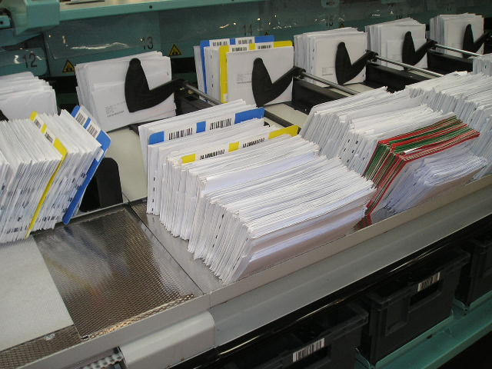

- It may also be helpful to turn mail in stacks 1-12 to provide more capacity in case the stackers overflow whilst re-feeding, by lifting the paddle and inserting towards the rear of the mail stack. Turn the mail in front of the paddle and store in the stacker.

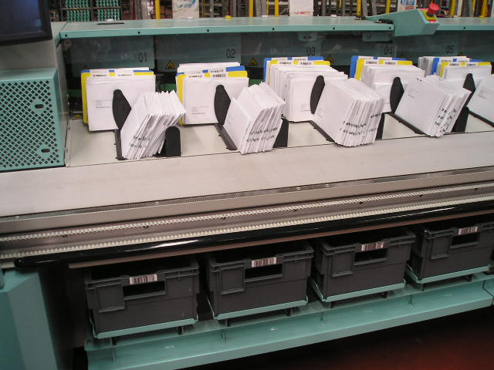

- During the first pass, as soon as the mail in the feeder clears past stacker 1, place stacker 1 mail onto the in-feed behind the green separator cards to ensure the machine is not waiting for mail when it commences the next pass.
- Mail must then be swept from stacker 2 & 3 ensuring any mail that has been turned is placed on the feeder in front of the mail that is behind the paddle.
- The next pass can now commence by switching on the feeder.
- This process is now repeated clearing the remaining stackers taking care to ensure that any mail that has been turned in stackers 4 – 12 or placed against the retaining ridge in stackers 13 – 19 is placed on the feeder in front of the mail that is behind the paddle in the corresponding stacker.
- When all the stackers have been cleared the green separator cards should be removed from the stackers and placed behind the last item in the mail stack on the feeder.
- The above processes are repeated at the end of pass 2.
- Towards the end of Pass 3, slide the mail in stacks 13 to 19 out of the stacker and leave against the retaining ridge of the machine bed. Do not put into trays.
- At the end of Pass 3 switch the feeder and conveyor off. This is not a necessity but does reduce noise within the work area,and reduces energy consumption of the CSS machine

Smaller batches. (eg Wave 2)

- During the first pass, as soon as the mail in the feeder clears past stacker 1, place stacker 1 mail onto in-feed behind the green separator cards to ensure the machine is not waiting for mail when it commences the next pass.
- Mail must then be swept from stacker 2 & 3
- The next pass can now commence by switching on the feeder.
- This process is now repeated clearing the remaining stackers.
- When all the stackers have been cleared the green separator cards should be removed from the stackers and placed behind the mail stack on the feeder.
- The above processes are repeated at the end of pass 2.
- Smaller batches should not require overflow management. This provides an opportunity to load mail for the next batch to the static bed plate whilst the machine is running pass 3, therefore reducing loading time. It is recommended that an upturned tray remains at the front of the mail stack to prevent it from falling forward on to the moving conveyor.
- At the end of Pass 3 switch the feeder and conveyor off. This is not a necessity but does reduce noise within the work area and reduces energy consumption of the CSS machine

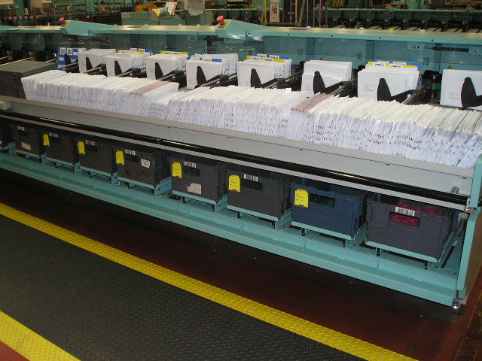

Cleardown

- Move the sliding trolley from its position in front of stacker 20 to a position in front of stacker 1.
- Obtain a tray from the rack under stacker 1 and place on top of the sliding trolley. This is repeated for all stackers on the machine.
- If mail for a walk looks to require more than one tray then the mail should be split between the trays as evenly as possible to reduce tray over and under filling.
- Remove the Walk separator card (BLUE) from the start of the walk and put it to one side on the machine to use again when processing the next batch
- Remove the postcode separator (YELLOW) card from the stack of mail and band the postcode sorted mail in a bundle to distinguish it from the DP sequenced mail.

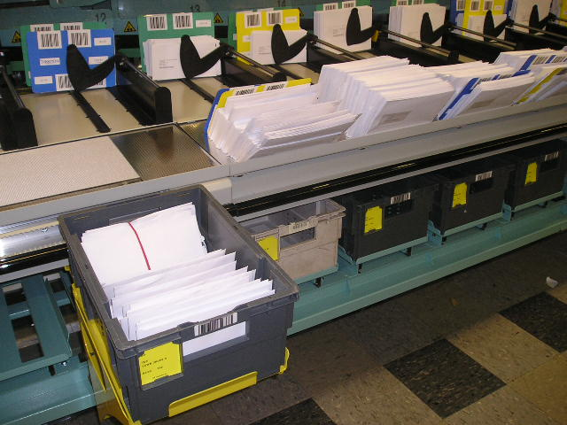

- A second tray can be placed on top of the first tray and the process repeated.
- The trays should then be moved on the sliding trolley adjacent to the despatch York.
- Each tray should then be individually lifted and placed in the despatch York. (DO NOT LIFT MORE THAN ONE TRAY AT A TIME)
- If additional trays are required, these can be obtained from the store of empties contained within the York that was placed in the area during area setup.
- During the three pass sequence process an appropriate number of tray labels should be produced from the pre-printed label holder or the on demand labelling system.
- Clear the mail from the stack into the tray and insert the label into the label holder on the front of the tray. Repeat the process as necessary for subsequent trays.
- Clear mail from stackers between the walk separator cards (BLUE) into a tray and label the tray as detailed in the section to the right.
- Cleardown stacks 1 – 12 to trays and put the trays into an empty York. The empty York will be the one that the batched mail arrived in.
- Load the equivalent number of trays (equal to the number of trays removed in the cleardown process above) from the next batch of mail and put the empty trays to the racks underneath the infeed conveyor. If loading from loose letter racks then load to the end of the infeed belt.
- If the batches are small and mail has been pre-loaded to the static bed plate, sweep the mail to the feeder.
- To maintain the overlap process during an operator changeover, the new operator can commence loading the next batch as soon as the finishing operator has cleared down to stacker 12 or at the appropriate point if running a smaller batch. Mail MUST NOT be loaded on to the feeder belt in front of stackers that are still to be cleared.
- Select the new batch plan for processing on the HMI and press OK.
**IMPORTANT**
- A mail search should be undertaken between batches and following completion of the final batch to ensure any items that have remained in the machine are located and despatched with the batched mail.

- Press the conveyor on and when the machine informs you (by a steady light) switch the feeder on and whilst the machine starts to process the next batch, clear down the remaining stacks (13 – 19)
- Following completion of the final batch the machine and work area must be left in a tidy condition with all separator cards placed back in the rack above the feeder.

- The CSS machine should be switched OFF at the OCP and all covers closed.

Other Sorting Functionality

The CSS can also be used for other sorting functions by selecting the appropriate icon on the toolbar.

Walk Sorting

In the event of a CSS failure in a multi machine site that cannot be quickly rectified, the contingency to ensure all work can be despatched on time and may require another machine to be switched to walk sorting, with the batches for both machines walk sorted rather than sequenced. Walk Sorting requires only a single pass through the machine.

There may be specific times of the year when it is desirable to use the walk sorting function. For example during the Christmas period when arrival profiles and volumes fluctuate creating a distortion in batch sizes and availability. Also the percentage of mail that is fully coded drops significantly giving rise to a very high level of rejects. Under these circumstances it may be preferable to walk sort the batch rather than sequence.

In a walk sorting mode, the CSS will allocate an individual stacker to each walk. It is therefore possible to walk sort up to 19 walks on a walk sort plan with stacker 20 used for rejects.

Mail presentation from the Inward Sort process should be identical to sequencing, with batches of walks made up to the same configuration.

Layout of equipment around the CSS should also be identical. The only difference will be the label sets that should be identifying walk sorted rather than DP sequenced letters.

Loading a Walk Sorting Plan

Load the appropriate Operating mode and Sort plan. Using the CSS touchscreen (HMI) and pressing the appropriate icons on the HMI screen:
- Log in to system as an Operator
- Select Walk Sorting mode.
- Select batch group Walk sort plan.
Select the walk sorting mode using the icons at the top of the HMI.

Next select the sort plan from the list displayed by touching the appropriate plan and then OK.

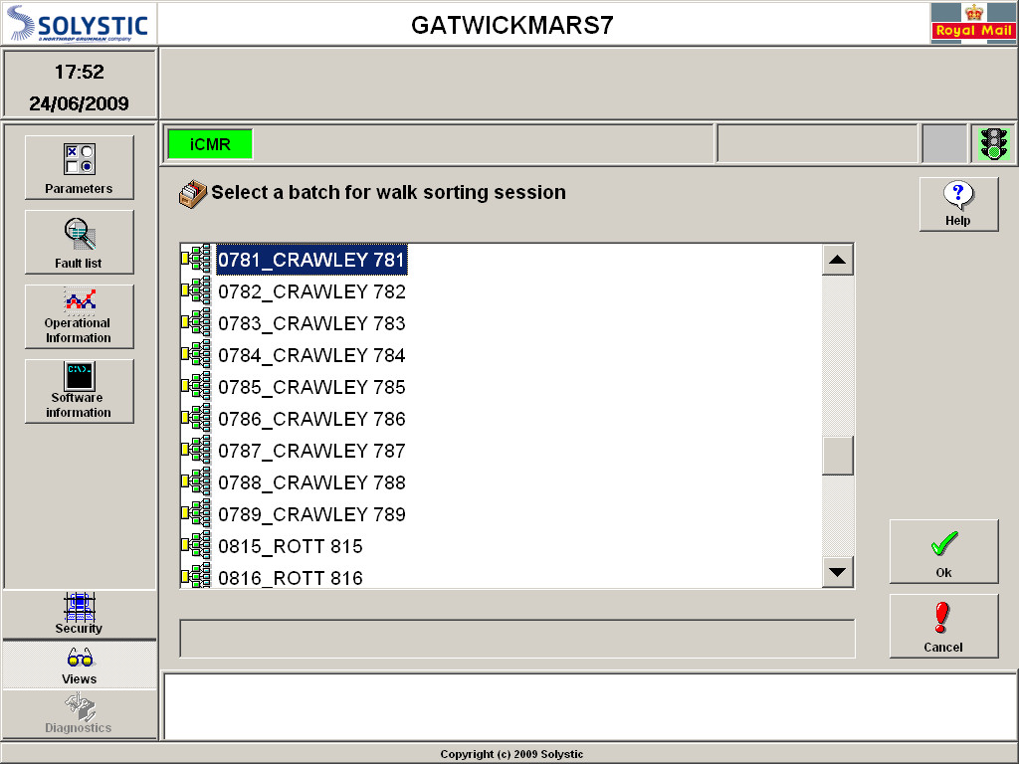

The sort plan will now load.

Select the “Selected Walks” tab. You will now see a display that cross references each walk within the batch to a stacker number
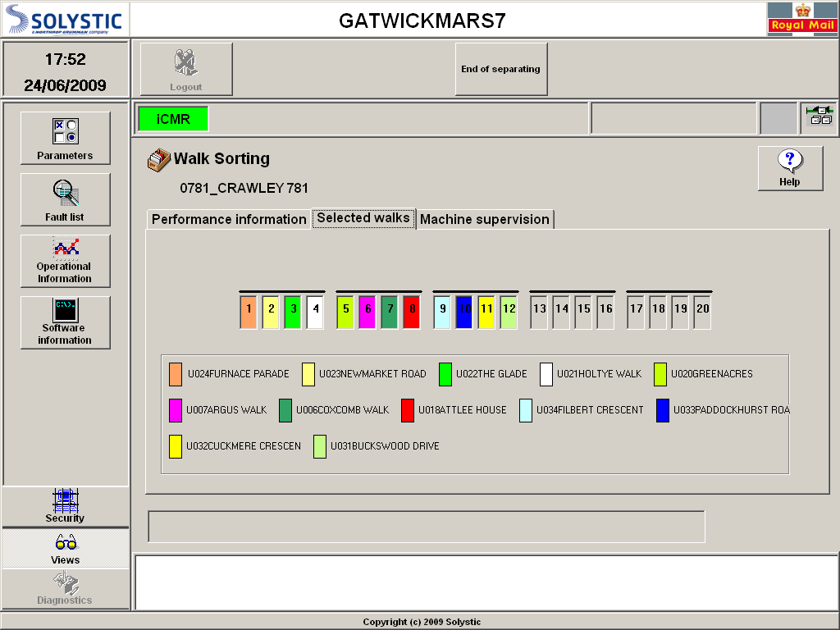

Trays should now be labelled and inserted in the tray rack below the feeder aligned to the appropriate stacker.

Load the Mail

- Load 5 trays of mail on to the infeed. Mail must be orientated with the indicia upwards and the back of the mail towards the feeder belt. Put the empty trays into a York of empty trays for future use.
- If tipping a tray, the recommended method is to rest the tray on the front edge of the machine and tip the tray forwards. Spinning a tray towards you is not recommended as this causes excessive stress to the wrists and can result in injury.
- If mail is inverted with the indicia up, place the tray on the sliding trolley, adjacent to the loading area and lift mail on to the feeder in manageable size bundles. This ensures that the tray is at the correct height for lifting the mail. It is also recommended that mail handling gloves are worn for both protection and to aid the gripping of the mail.
- If loading from a loose letter rack then load one tier.
- It is important to ensure that mail is referenced to its bottom edge, not packed too tightly, is leaning backward and the Feeder pushplate is against the stack.. This reduces the risk of feeder jams.
- Press OK on the Operator Control Panel (OCP)l. (As soon as you press OK the MIS counter starts).
- Press the conveyor ON and when machine informs you (by a steady light) press the feeder ON button.
- Load the remaining trays of mail or tiers of the loose letter rack. Again place the empty trays in the York of empty trays.
- When the final tray of mail has been loaded insert 20 green separator cards (Not required on final session).

Clearing the Mail

- As the mail is sorted, stackers should be cleared on a regular basis. The tray rack should be pulled out below the stacker and then pushed back. Under no circumstances should the sliding tray racks be left out as they create a safety hazard.
- When a tray is full it should be removed to the despatch York and replaced with a labelled empty tray.
- If only small volumes are sorted it may be preferable to make up banded and labelled bundles that can be mixed in trays.
- Any mail that is rejected should be placed in a tray that should be positioned on the sliding trolley adjacent to stacker 20. When the tray is full or on completion of the batch it should be removed from the sliding trolley and sent to the primary sorting area. If this is within another office then the rejects should be sent in the same York as the sequenced mail and clearly labelled as rejects from batch xxx.
NOTE: A BLUE LABEL MUST BE USED FOR CSS REJECT TRAYS INDICATING THAT ANY RESPONSE SERVICE ITEMS WITHIN THE TRAY HAVE BEEN AUTOBILLED

- On completion of the batch, fully clear the first five stackers and then re-load the feeder with the next batch.
- Select the next walk sort plan, press start and complete clearing of the remaining walks, ensuring mail for the following batch remains topped up on the feeder.
- Following completion of the final walk sort plan the machine and work area must be left in a tidy condition with all separator cards placed back in the rack above the feeder.

- The CSS machine should be switched OFF at the OCP and all covers closed.

Batch Sorting

There is a facility on the CSS to create batches for subsequent walk sorting or sequencing. This should only be used in exceptional circumstances as this is far less efficient than the batching process on an IMP or iLSM. It is recommended that an additional operator is used when batch sorting as continuous feeding and clearing will occur in parallel.

Under no circumstances should mail that contains items that require automatic billing for response services be batch sorted on a CSS.

Customer Bar Code Mail is suitable for batch sorting on a CSS, particularly if it is subsequently to be walk sorted only. The bar codes although fully coded to delivery point level will often contain a default DP suffix and cannot therefore be sequenced fully and will remain as post code sorted at the rear of the mail stack for each walk. For sequencing, it is important that CBC is batch sorted on an IMP or iLSM where the AI system can apply a printed route code fully to DP level.

Layout of equipment around the CSS will differ for batch sorting. It is possible to place 8 York containers in front of the machine with space for a further York containing the mail to be batched. It is recommended that each York is divided in the centre giving the opportunity to sort to 16 batches. Remove the first three stackers from use leaving stackers 4 to 19 for sorting with stacker 20 for rejects. This allows the operator at the feeder to maintain a continuous feeding operation whilst a second operator can clear the stackers without interference from the mail on the feeder belt.

8 Yorks divided left and right for 16 batch breakdown
Mail for batching
Retaining Ridge
Moving Infeed Belt
Static machine bed plate

Sliding
Trolley
X
X
X
R

Loading a Batch Sorting Plan

Load the appropriate Operating mode and Sort plan. Using the CSS touchscreen (HMI) and pressing the appropriate icons on the HMI screen:
- Log in to system as an Operator
- Select Batch Sorting mode.
- Select batch group sort plan.
Select the batch sorting mode using the icons at the top of the HMI.

Next select the sort plan from the list displayed by touching the appropriate plan and then OK.

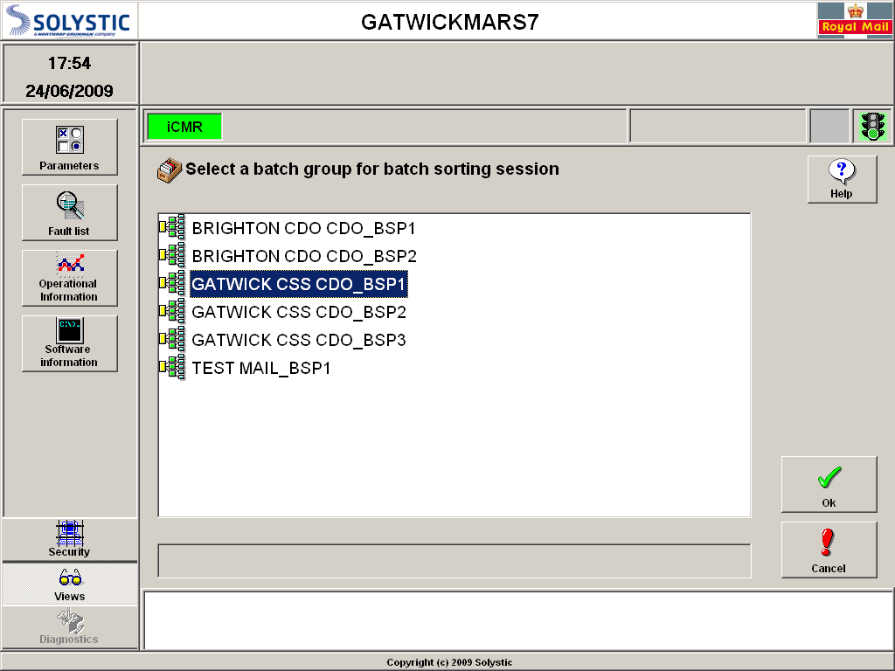

The sort plan will now load.

Select the “Selected Batch” tab. You will now see a display that cross references each batch to a stacker number

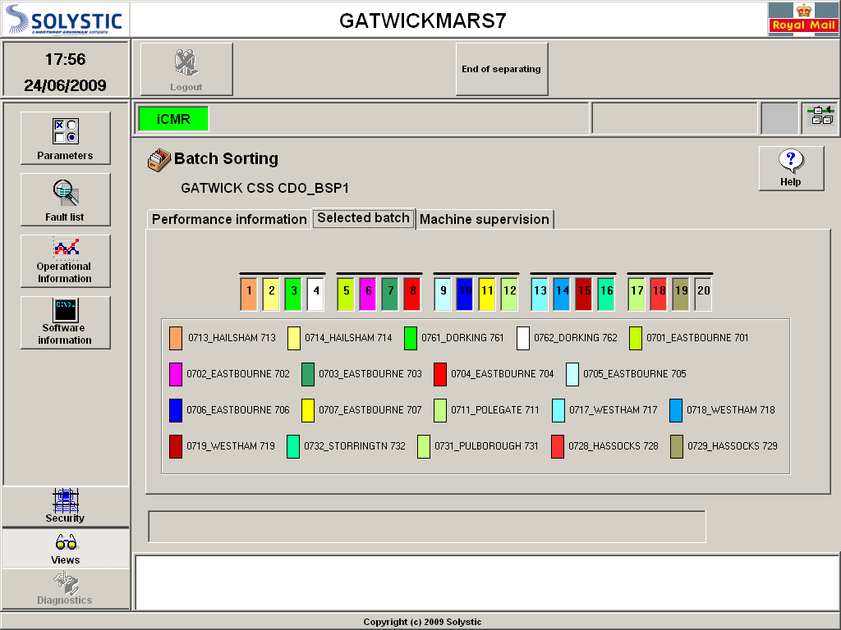

Trays should now be labelled and inserted in the tray rack below the feeder aligned to the appropriate stacker.

Load the Mail

- Load 5 trays of mail on to the infeed. Mail must be orientated with the indicia upwards and the back of the mail towards the feeder belt. Put the empty trays into a York of empty trays for future use.
- If tipping a tray, the recommended method is to rest the tray on the front edge of the machine and tip the tray forwards. Spinning a tray towards you is not recommended as this causes excessive stress to the wrists and can result in injury.
- If mail is inverted with the indicia up, place the tray on the sliding trolley, adjacent to the loading area and lift mail on to the feeder in manageable size bundles. This ensures that the tray is at the correct height for lifting the mail. It is also recommended that mail handling gloves are worn for both protection and to aid the gripping of the mail.
- If loading from a loose letter rack then load one tier.
- It is important to ensure that mail is referenced to its bottom edge, not packed too tightly and is leaning backwards. This reduces the risk of feeder jams.
- Press OK on the Operator Control Panel (OCP). (As soon as you press OK the MIS counter starts).
- Press the conveyor ON button and when machine informs you (by a steady light) press the feeder ON button
- Load the remaining trays of mail or tiers of the loose letter rack. Again place the empty trays in the York of empty trays.
- When the final tray of mail has been loaded insert 20 green separator cards (Not required on final session).

Clearing the Mail

- As the mail is sorted, stackers should be cleared on a regular basis. The tray rack should be pulled out below the stacker and then pushed back. Under no circumstances should the sliding tray racks be left out as they create a safety hazard.
- When a tray is full it should be removed to the despatch York and replaced with a labelled empty tray.
- On completion of the batch sort plan, fully clear the first five stackers and then re-load the feeder.
- Select the next batch sort plan, press start and complete clearing of the remaining batches ensuring mail on the feeder remains topped up.
- Following completion of the final batch sort plan the machine and work area must be left in a tidy condition with all separator cards placed back in the rack above the feeder.

- The CSS machine should be switched OFF at the OCP and all covers closed.

